**CO-2 Notes**

Survey Components of UI & Effective UI Design Process: Menu Selection, Form Filling, Dialog Boxes-Introduction, Task Related Organization, Item Presentation Sequence, Response time and Display Rate, Fast Movement through menus, Menu Layout, Form Filling, Dialog Boxes, Interactive Devices, Specification methods, Interface Building tools, Evaluation and pretty critiquing tools

**Survey Components of UI Design:-**

UI (User Interface) design is a critical aspect of creating user-friendly and visually appealing digital products. A well-designed user interface enhances user experience and helps users interact with the software or application efficiently. Here are some essential components of UI design:

1. **Layout:** The arrangement of elements on the screen is crucial for creating a clear and organized user interface. A good layout ensures that the important elements are easily accessible and that the overall design is visually balanced.
2. **Typography:** The choice of fonts and how they are used in the interface can greatly impact readability and aesthetics. Consistent and appropriate typography helps guide users through the content.
3. **Color Scheme:** Colors play a significant role in UI design, affecting the emotional response and usability. A well-chosen color scheme enhances the overall look and feel of the interface and can help convey information hierarchy.
4. **Icons and Graphics:** Icons and graphics are visual representations of actions or elements in the interface. They should be intuitive, easy to understand, and consistent with the overall design style.
5. **Buttons and Controls:** Buttons and controls are interactive elements that allow users to perform actions or submit inputs. They should be easily identifiable and should have visual cues indicating interactivity.
6. **Forms and Input Fields:** Forms and input fields are used to gather information from users. They should be designed in a way that encourages completion and reduces the chance of errors.
7. **Feedback and Notifications:** Providing feedback to users about their actions or the system's status is essential for a good user experience. This can be in the form of success messages, error messages, or notifications.
8. **Responsiveness:** With the increasing use of various devices, including smartphones, tablets, and desktops, it's important to design UI that adapts to different screen sizes and resolutions.
9. **Consistency:** Consistency in UI design helps users understand and learn the interface faster. Consistent use of elements, colors, typography, and interactions creates a cohesive and familiar experience.
10. **Accessibility:** UI design should consider accessibility guidelines to ensure that all users, including those with disabilities, can access and use the product.

**Effective UI Design Component:-**

Creating an effective User Interface (UI) design involves a systematic process to ensure that the final product is user-friendly, visually appealing, and functional. Here's a step-by-step guide to an effective UI design process:

1. **Research and Understand Users:**
   * Identify your target audience and their needs.
   * Conduct user research, surveys, and interviews to gather insights.
   * Create user personas to represent different user types and their goals.
2. **Define Goals and Objectives:**
   * Clearly outline the purpose of the UI design.
   * Set measurable goals and success criteria for the design.
   * Identify key user tasks and prioritize them.
3. **Information Architecture:**
   * Organize content and functionality logically.
   * Create a sitemap or flowchart to visualize the navigation structure.
   * Focus on creating a clear and intuitive user flow.
4. **Visual Design:**
   * Choose a color palette, typography, and visual style that align with the brand and target audience.
   * Design high-fidelity mockups that reflect the final look and feel of the UI.
   * Pay attention to spacing, alignment, contrast, and other design principles.
5. **Prototyping:(Prototyping is an experimental process where design teams implement ideas into touchable forms from paper to digital)**
   * Create interactive prototypes to simulate user interactions.
   * Test different scenarios and user flows within the prototype.
   * Gather feedback from stakeholders and potential users to refine the design.
6. **Usability Testing:**
   * Conduct usability testing with real users to identify usability issues.
   * Analyze user feedback and make necessary adjustments to the design.
   * Iterate on the design based on the insights gained from testing.
7. **Implementation and Development:**
   * Collaborate closely with developers to ensure the design is accurately implemented.
   * Provide detailed design specifications and assets for developers to reference.
8. **Quality Assurance (QA):**
   * Thoroughly test the UI across different browsers and devices to identify and fix any bugs or inconsistencies.
   * Check for alignment, spacing, color accuracy, and other design-related elements.

**Menu selection:-**A menu displays a list of choices on a temporary surface. They appear when users interact with a button, action, or other control.

**Types**

Menus allow users to make a selection from multiple options. They are less prominent and take up less space than selection controls, such as a set of radio buttons.

There are two types of menus: 1. Dropdown menus (overflow, context, popup, and list popup window menus), 2. [Exposed dropdown menus](https://m2.material.io/components/menus" \l "exposed-dropdown-menus" \t "_self).

**<https://dribbble.com/shots/3810153-Shorebox-Admin-Menu-Selection>**

## What are dropdown menus

Dropdown menus are a classic [UI design](https://www.justinmind.com/ui-design) component. Users see them everywhere, serving all kinds of ends, such as helping people fill out forms

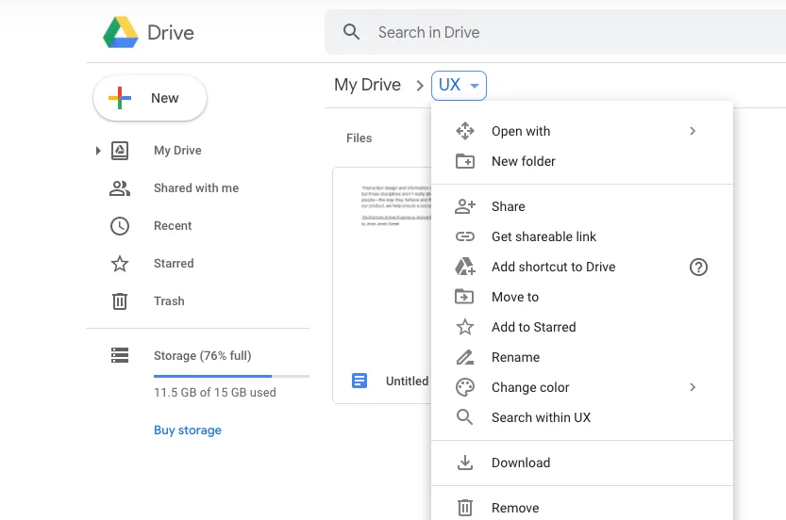

Usually from the [UI sketching](https://www.justinmind.com/ui-design/sketching) phase, drop downs are a beloved classic. Usually, any given drop down menu will work as one of the following functions:

* **Command menus**: When expanded, the menu helps users get more control over the interface, as they are presented with more buttons. A classic example is Word or Google Docs’ use of drop down menus.
* **Navigation menus**: Common in horizontal navigation bars as a way to offer more links to users, a clear example is our own navigation bar on the Just in mind website.
* **Form filling**: This can be a handy way to let users choose from many different options, such as can be the case when selecting a type of room in a hotel website, or how many people will be staying. Check our [research survey examples](https://www.justinmind.com/ui-design/research-survey-examples) for more on that.
* **Attribute selection**: The dropdown allows users to choose a value from many options, acting in a similar way to a form filling dropdown.

**EXPOSED DROP DOWN MENU:-**

The Exposed Drop-Down menu is the replacement for Spinner in Android because Spinner is not that customizable like the new exposed Drop-Down menu.

dropdown Menus allow users to **make a selection from multiple options**. here we customize an exposed dropdown menu using a TextInputLayout and an AutoCompleteTextView.

You can also [create Spinner for dropdown menu](https://computerpathsala.com/create-spinner-with-strings-taken-from-resource-folder-on-changing-spinner-value-change-background-of-screen/" \t "_blank) with same functionality And different design. here are the demo for what we are going to create.

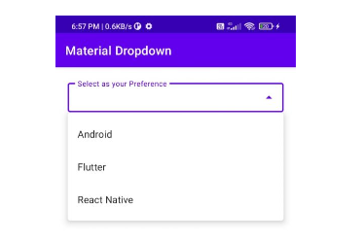

**Form Filling:-**

Forms are everywhere. Every time you log into a website, sign up for a newsletter, or reply to a WhatsApp message—you’re using a form.

Forms are crucial for the success of a design, both visually and for business purposes.

From a user interface (UI) design perspective, a form is an **element that allows the user to send information to a server**. We might imagine a form looking (and behaving) like the piece of paper you fill out when joining a gym.

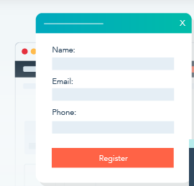 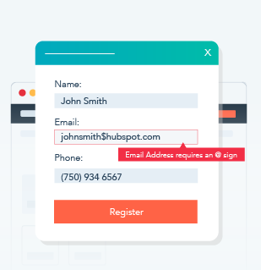

Since forms are one of the essential ingredients of website functionality, it’s critical for UX/UI designers to get them right. Building effective forms can help you create a much more delightful, usable, and inclusive user interface design—ultimately benefiting both your UX and your project’s goals.

**Dialog Boxes Introduction:-**

A Dialog Box **can be used when you want to display a modal window** to the user.

This is typically used when the application needs to ask the user for some required information before continuing with an operation.

Dialog Boxes can be opened directly from the navigator or [started](https://docs.ifs.com/techdocs/Foundation1/050_development/022_user_interface/045_ee_dev/027_apf_development/800_references/020_window_level_activities/620_add_navigation_between_forms.htm" \l "Start_a_Dialog) through an action performed in another window.

When the dialog is open, the rest of the application will not be accessible until the Dialog Box is closed.

Dialog Box Launchers are small icons that appear at the bottom corner of some groups.

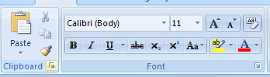

Point to a Dialog Box Launcher to display a ScreenTip.

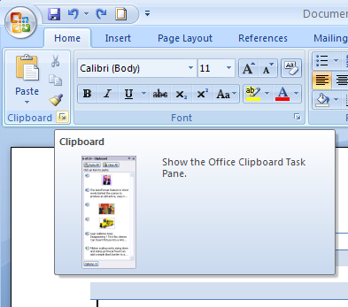

A dialog box allows you to supply more information.

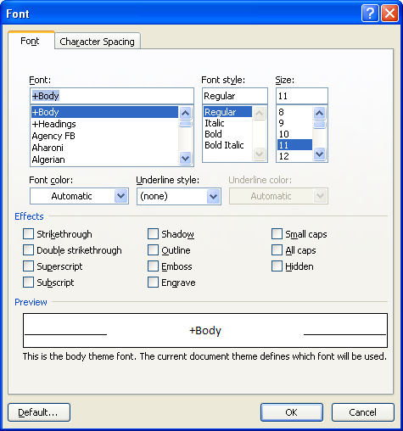

After entering information in a dialog box, click the OK button to complete the command.

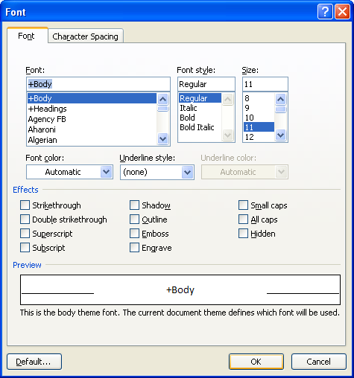

Click the Cancel button to close the dialog box without issuing the command.

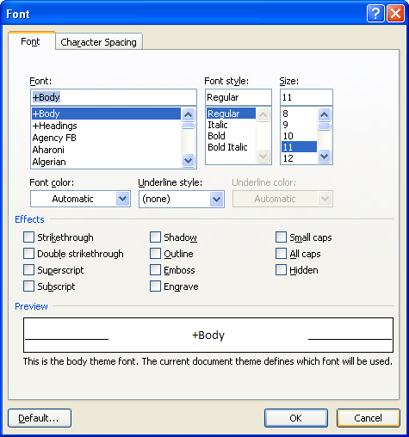

In many dialog boxes, you can also click an Apply button to apply your changes without closing the dialog box.

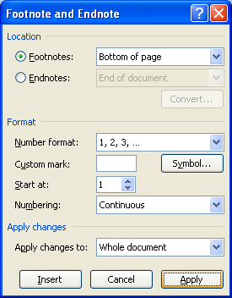

You can press the Tab key to move keyboard focus from one component to the next.

You can use Shift+Tab to move backward.

You can use Ctrl+Tab and Ctrl+Shift+Tab to move between dialog box tabs.

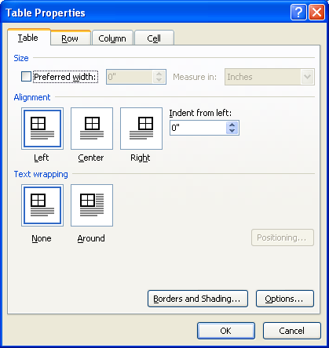

**Task Related Organization:-**

When designing your interface, try to be consistent and predictable in your choice of interface elements. Whether they are aware of it or not, users have become familiar with elements acting in a certain way, so choosing to adopt those elements when appropriate will help with task completion, efficiency, and satisfaction.

Interface elements include but are not limited to:

* **Input Controls**: checkboxes, radio buttons, dropdown lists, list boxes, buttons, toggles, text fields, date field
* **Navigational Components**: breadcrumb, slider, search field, pagination, slider, tags, icons
* **Informational Components**: tooltips, icons, progress bar, notifications, message boxes, modal windows
* **Containers**: accordion

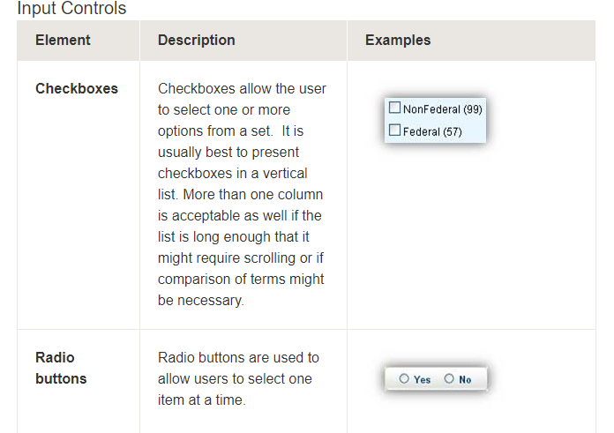

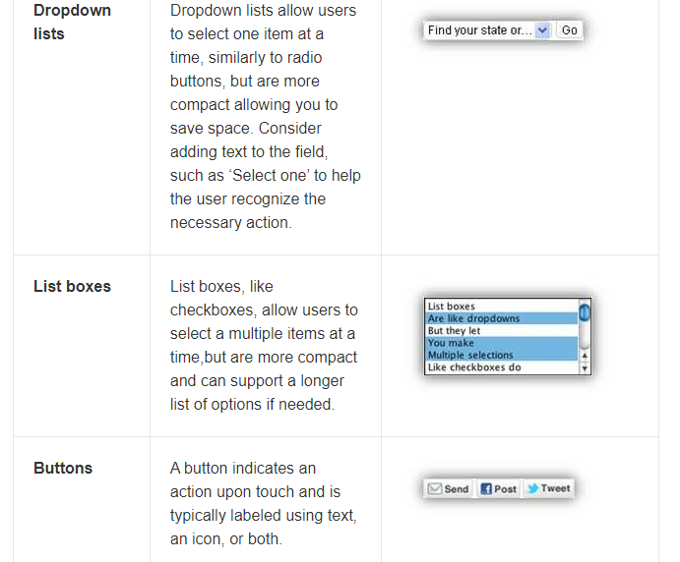

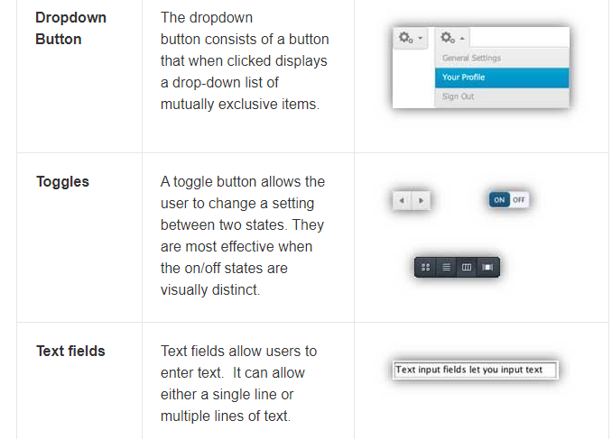

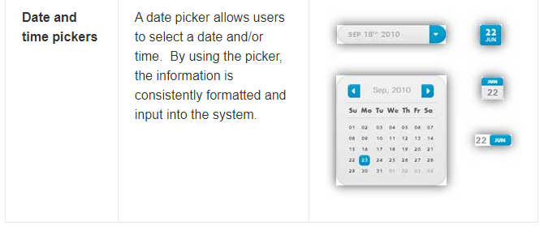

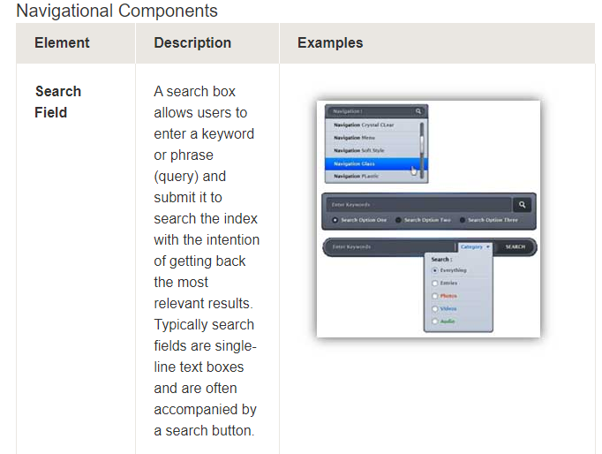

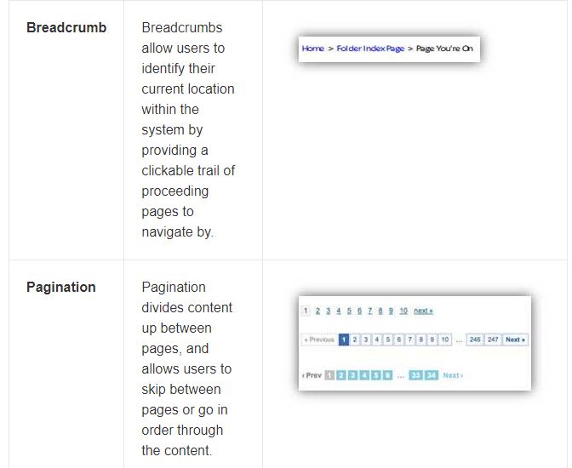

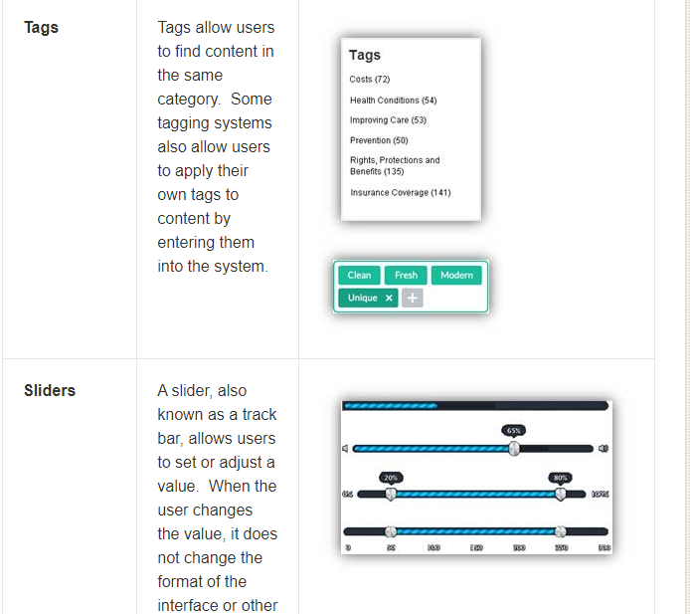

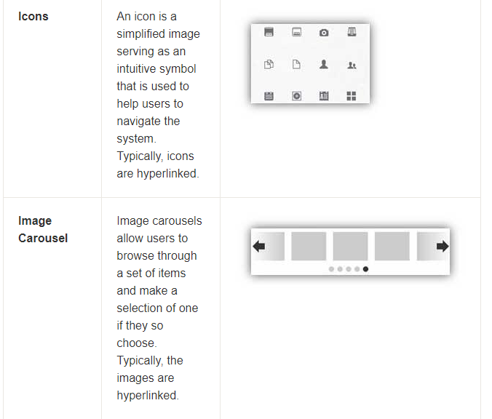

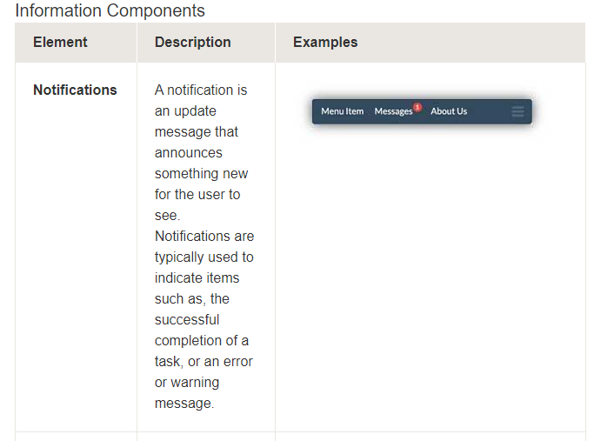

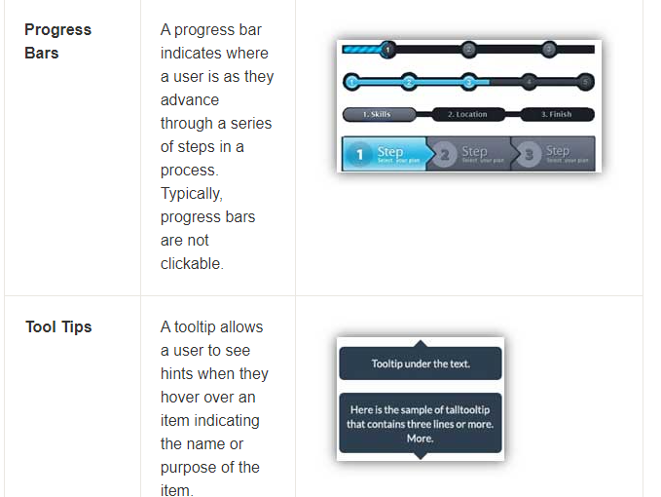

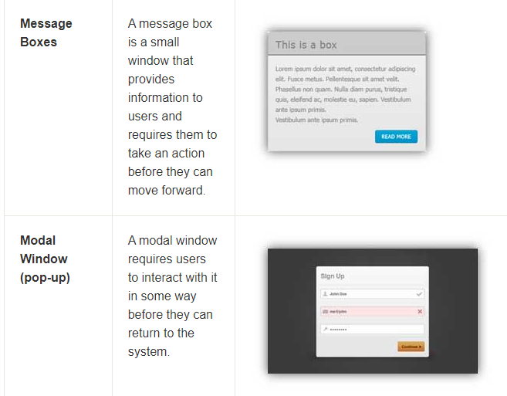

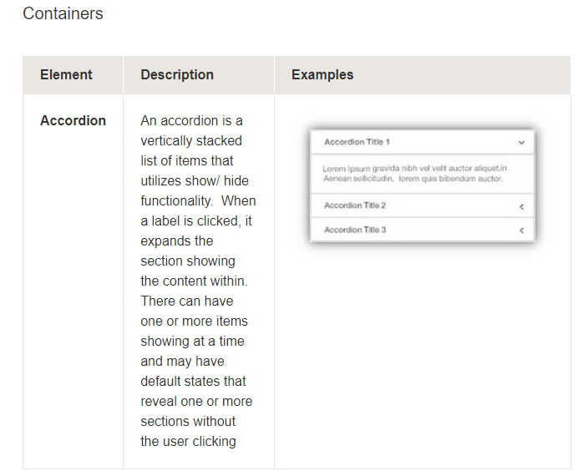

<https://uxdesign.cc/selection-controls-ui-component-series-3badc0bdb546>

**ITEM PRESENTATION SEQUENCE:-**

In the context of UI (User Interface) components, an "Item Presentation Sequence" typically refers to the order in which items or elements are presented to the user within a user interface. This sequence can be crucial for providing a smooth and intuitive user experience.

1. **Navigation Menus or Lists**: In navigation menus, lists, or dropdowns, items are usually presented in a specific sequence. This sequence can be based on factors such as importance, relevance, or user behavior. For example, in a dropdown menu, the most frequently accessed options might be presented at the top for quicker access.
2. **Sliders and Carousels**: In UI components like image sliders or carousels, items are presented in a sequential manner, allowing users to navigate through a series of images or content. The order of items and the transition effects can influence the user's perception and engagement.
3. **Wizard or Step-by-Step Interfaces**: In multi-step processes or wizards, items are presented in a specific sequence to guide the user through a series of tasks. Each step typically represents a stage in the process, and the order of presentation is crucial to ensure a logical and coherent flow.
4. **Forms and Input Fields**: When designing forms or input fields, the order in which fields are presented can impact the user's experience. Organizing fields in a logical sequence or grouping related fields together can help users fill out forms more efficiently.
5. **Tabbed Interfaces**: Tabbed interfaces often present different sets of content or functionalities in a tabbed format. The sequence of tabs can influence how users access and interact with different sections of the interface.
6. **Product Listings**: In e-commerce interfaces, the presentation sequence of products can influence user browsing and purchasing behavior. Items can be sorted by factors such as relevance, price, popularity, or user preferences.
7. **Notifications and Alerts**: When presenting notifications or alerts to users, the order in which they appear can impact their attention and response. Important or urgent notifications might be presented first.
8. **Content Layout**: In content-rich interfaces, such as news websites or social media feeds, the sequence in which content is presented can influence user engagement. Algorithms may determine the order of posts based on various factors.

**<https://careerfoundry.com/en/blog/ui-design/ui-element-glossary/>**

**Response time and display rate in UI Component:-**

Response time and display rate are important aspects of user interface (UI) design that impact the overall user experience. Let's break down what each term means and how they relate to UI components:

1. **Response Time**: Response time refers to the time it takes for a system or UI component to react to a user's input or action. It is the delay between the user's action (e.g., clicking a button, typing, swiping) and the system's feedback or output. A fast response time is crucial for creating a responsive and intuitive user interface.

For example, when a user clicks a button, they expect to see an immediate visual indication that their action has been registered, such as a button highlighting or changing its appearance. Similarly, when typing in a text field, the characters should appear on the screen without noticeable delay.

A slow response time can lead to user frustration, as it may give the impression that the system is unresponsive or malfunctioning. In UI design, minimizing response time is important for providing a seamless and enjoyable user experience.

1. **Display Rate** (Refresh Rate): Display rate, also known as refresh rate, refers to the number of times per second that a display updates its content. It is usually measured in Hertz (Hz). A higher refresh rate means smoother motion and transitions on the screen. Common refresh rates include 60Hz, 120Hz, and 144Hz.

Higher refresh rates can contribute to a more visually appealing UI by reducing motion blur and flickering. This is particularly important in applications that involve animation, video playback, or fast-paced interactions.

When designing UI components, it's important to consider both the response time and display rate to ensure a cohesive and fluid user experience. Here are some considerations:

* **Responsiveness**: UI components should provide immediate feedback to user interactions. For instance, buttons should visually respond to clicks, and forms should show instant validation messages.
* **Animation**: If your UI includes animations or transitions, consider the display rate of the screen. Animations should be smooth and not jittery, especially on displays with higher refresh rates.
* **User Perception**: Users' perception of response time can be influenced by factors such as animation speed, loading indicators, and feedback messages. Adjust these elements to create the perception of a faster response time.
* **Optimization**: Ensure that your UI components are optimized for performance. Slow response times can often be attributed to inefficient code or network delays. Aim to minimize any bottlenecks that could lead to delays.
* **Compatibility**: Be mindful of the devices your UI will be used on. Different devices may have varying display rates, and **your design should be adaptable to provide a good experience across different platforms.**

**FAST MOVEMENTS THROUGH MENU’S-FORM FILLING,CHECK BOXES AND DIALOG BOXES:-**

Once the general construction of the menu has been completed, it is ideal to allow expert users the ability to speed through menu selections. This can be done with shortcuts yet again, shortcuts need to follow general rules of menu selection by grouping like items and when there is no group giving shortcuts intuitive key presses.

# Data Entry with Menus: Form Fill-In, Dialog Boxes, and Alternatives

Previous sections have shown how to enter some data but when it comes to things that are more specific one must make use of items such as the form fill-in, and dialog boxes.

**Design Guidelines:**  
1) Meaningful titles  
2) Comprehensible instructions  
3) Logical grouping and sequencing of fields  
4) Visually appealing layout of the form  
5) Familiar field labels  
6) Consistent terminology and abbreviations  
7) Visible space and boundaries for data entry fields  
8) Consistent cursor movement  
9) Error correction for individual characters and entire fields  
10) Error prevention where possible  
11) Error messages for unacceptable values  
12) Marking of required fields  
13) Explanatory messages for fields  
14) Completions signal to support user control

**Format Specific Field**  
**1) Coded Fields**  
a. Telephone numbers  
b. Social-security numbers  
c. Date and Times

**2) Dialog Boxes** is a combination of both menus and form fill-in techniques

**Internal Layout Guidelines:**  
1) Meaningful title, consistent style  
2) Top-left to bottom-right sequencing  
3) Clustering and emphasis  
4) Consistent layouts  
5) Consistent terminology  
6) Standard Buttons (OK, Cancel)  
7) Error prevention by direct manipulation

**External Layout Guidelines:**  
1) Smooth appearance and disappearance  
2) Distinguishable but small boundary  
3) Size small enough to reduce overlap problems  
4) Display close to appropriate items  
5) No overlap of required items  
6) Easy to make disappear  
7) Clear how to complete/cancel

**INTERACTIVE DESIGN IN UI COMPONENT:-**

Several interactive devices are used for the human computer interaction. Some of them are known tools and some are recently developed or are a concept to be developed in the future. In this chapter, we will discuss on some new and old interactive devices.

## **Touch Screen**

The touch screen concept was prophesized decades ago, however the platform was acquired recently. Today there are many devices that use touch screen. After vigilant selection of these devices, developers customize their touch screen experiences.

In HCI, touch screen can be considered as a new interactive device.

## **Gesture Recognition**

Gesture recognition is a subject in language technology that has the objective of **understanding human movement via mathematical procedures**. Hand gesture recognition is currently the field of focus. This technology is future based.

This new technology magnitudes an advanced association between human and computer where no mechanical devices are used. This new interactive device might terminate the old devices like keyboards and is also heavy on new devices like touch screens.

## **Speech Recognition**

The technology of transcribing spoken phrases into written text is Speech Recognition. Such technologies can be used in advanced control of many devices such as switching on and off the electrical appliances. Only certain commands are required to be recognized for a complete transcription. However, this cannot be beneficial for big vocabularies.

This HCI device help the user in hands free movement and keep the instruction based technology up to date with the users.

## **Keyboard**

A keyboard can be considered as a primitive device known to all of us today. Keyboard uses an organization of keys/buttons that serves as a mechanical device for a computer. Each key in a keyboard corresponds to a single written symbol or character.

This is the most effective and ancient interactive device between man and machine that has given ideas to develop many more interactive devices as well as has made advancements in itself such as soft screen keyboards for computers and mobile phones.

## **Response Time**

Response time is the time taken by a device to respond to a request. The request can be anything from a database query to loading a web page. The response time is the sum of the service time and wait time. Transmission time becomes a part of the response time when the response has to travel over a network.

**SPECIFICATION METHODS:-**

Specification methods in UI component development refer to the process of defining and describing the behavior, appearance, and interactions of a user interface (UI) component. These methods help ensure that the design and development of **UI components are consistent**, well-documented, and align with the overall user experience and design guidelines of the application or system. Here are some common specification methods used in UI component development:

1. **Design Mockups and Wireframes(Visual representation of web page structure):** Design mockups and wire frames are visual representations of how the UI component should look and function. These can be created using design tools like Adobe XD, Sketch, Figma, or even simple paper sketches. They provide a clear visual reference for developers, helping them understand the layout, visual elements, and interactions of the component.
2. **Style Guides and Design Systems:** Style guides and design systems outline the visual and interaction design principles of an application. They define typography, color schemes, spacing, button styles, and other design elements that should be used consistently across UI components. Design systems often include pre-designed UI components that can be reused throughout the application.
3. **Functional Specifications:** Functional specifications detail the intended behavior of a UI component. They describe how the component should respond to user interactions and system events. This includes details such as input validation, error handling, animations, and transitions.
4. **User Stories and Use Cases:** User stories and use cases describe scenarios in which the UI component will be used. They outline the steps a user takes to interact with the component and achieve specific goals. This helps developers understand the context in which the component will be used and design it accordingly.
5. **Interaction Diagrams:** Interaction diagrams, such as flowcharts or state diagrams, depict the flow of user interactions within the UI component. These diagrams illustrate how the component transitions between different states or screens based on user actions.

**INTERFACE BUILDING BLOCKS IN UI COMPONENTS:-**

Interface building tools are software applications or platforms that assist designers and developers in creating, prototyping, and building user interface (UI) components and layouts. These tools provide a visual and often code-free environment for designing, arranging, and testing UI elements. Here are some popular interface building tools used in UI component development:

1. **Figma:** Figma is a collaborative design tool that allows multiple designers and developers to work together in real-time on UI components. It offers features like interactive prototyping, vector editing, and design libraries, making it a popular choice for creating UI components and layouts.
2. **Adobe XD:** Adobe XD is another powerful design and prototyping tool that enables the creation of UI components, interactive prototypes, and user flows. It supports vector design, animation, and integration with other Adobe Creative Cloud apps.
3. **Sketch:** Sketch is a vector-based design tool exclusively for macOS. It's commonly used for creating UI components and offers plugins and libraries to enhance design workflows.
4. **InVision Studio:** InVision Studio combines design and prototyping capabilities, allowing designers to create interactive UI components and animations. It supports collaboration and integrates with other design tools.
5. **Axure RP:** Axure RP is a prototyping tool that focuses on interactive and dynamic UI components. It enables designers to create complex interactions and simulate user behavior.
6. **Balsamiq:** Balsamiq is known for its quick and low-fidelity wireframing capabilities. It's great for sketching out UI component ideas and layouts before moving to high-fidelity design.
7. **Webflow:** Webflow is a web design and development platform that allows designers to visually design and build responsive websites and UI components. It generates HTML, CSS, and JavaScript code as you design.
8. **Bootstrap Studio:** Bootstrap Studio is a UI design and development tool specifically tailored for building responsive web interfaces using the Bootstrap framework. It provides a drag-and-drop interface and real-time preview.
9. **Proto.io:** Proto.io is a prototyping tool that enables the creation of interactive and high-fidelity UI components and animations. It's suitable for testing complex interactions and user flows.
10. **Marvel:** Marvel is a platform for creating interactive prototypes and UI components. It offers integration with design tools like Sketch and Figma and allows designers to create prototypes directly from their designs.
11. **Origami Studio:** Origami Studio, developed by Facebook, is focused on creating interactive and animated prototypes. It's particularly useful for designing and testing complex interactions and animations.

**EVALUATING AND PRETTY CRITIQUING TOOLS:-**

Evaluating and critiquing UI components is an essential part of the design and development process to ensure that the components meet usability, accessibility, and design standards. There are several tools and methods available to help with evaluation and critique. Here are some tools and approaches you can consider:

1. **Usability Testing Platforms:**
   * **UserTesting:** UserTesting allows you to gather feedback from real users by conducting remote usability tests. Participants interact with your UI components while providing verbal and written feedback.
   * **Look back:** Lookback enables you to conduct remote or in-person user research sessions where you can observe participants interacting with your UI components and gather insights.
2. **Prototyping and Mockup Tools:**
   * **InVision:** InVision's collaborative features allow you to share interactive prototypes of your UI components with stakeholders and team members, facilitating feedback and critiques.
   * **Marvel:** Marvel's user testing feature lets you gather feedback by sharing prototypes with users and recording their interactions.
3. **Design Collaboration Platforms:**
   * **Figma:** Figma's real-time collaboration features allow designers, developers, and stakeholders to review and comment on UI components, facilitating discussions and critiques.
   * **Zeplin:** Zeplin simplifies the handoff process between designers and developers, allowing developers to view design specifications and provide feedback directly within the tool.
4. **Design Critique Tools:**
   * **CritiqueIt:** CritiqueIt is a tool specifically designed for providing and receiving design critiques. It offers features for adding comments, annotations, and discussions to design files.
   * **Notable by ZURB:** Notable is a design collaboration and feedback tool that allows you to annotate and discuss design components and layouts.
5. **Accessibility Evaluation Tools:**
   * **axe DevTools:** An accessibility testing tool that integrates with browser developer tools to help identify and fix accessibility issues in UI components.
   * **WAVE Web Accessibility Evaluation Tool:** WAVE is a browser extension that evaluates web pages, including UI components, for accessibility issues and provides visual feedback.
6. **Code Review and Collaboration Platforms:**
   * **GitHub/GitLab/Bitbucket:** These platforms offer code review features that allow developers to provide feedback on code changes related to UI components.
   * **Review Board:** Review Board is a web-based code review tool that helps teams collaborate on code changes and provide feedback.
7. **Online Forums and Communities:**
   * Platforms like **Stack Overflow** or **Designer News** can be used to share UI components or design concepts for public critique and feedback from the design and development community.